
K.R. MANGALAM UNIVERSITY

Name of Student – Aryan sethi
Roll NO. – 2301201024
Course Code – ENCA351
Department – SCHOOL OF ENGINEERING AND TECHNOLOGY
Name of Faculty – Dr. Aarti
Name of subject- Design and Analysis of
Algorithms Lab

Solving Real-World Problems Using Graph Algorithms

1. Introduction
Graph algorithms form the foundation of many real-world systems such as social networks, navigation systems, emergency response routing, and network design.
This project focuses on implementing four classical graph algorithms — BFS, Bellman-Ford, Dijkstra, and Prim’s MST — to solve practical problems in different domains.
Each problem demonstrates:
- How a real-world scenario can be represented as a graph
- Implementation of the appropriate algorithm
- Analysis of time complexity and performance
- Visualization of the resulting graph
2. Learning Objectives
By completing this project, I have:
- Implemented fundamental graph algorithms (BFS, DFS, Dijkstra, Bellman-Ford, MST).
- Understood how real-world problems map to graph structures.
- Analyzed algorithmic performance using time and memory profiling.
- Visualized graphs and interpreted relationships between nodes and edges.
- Documented findings with structured analysis and discussion.
3. Problem 1 – Social Network Friend Suggestion
Graph Algorithm: Breadth-First Search (BFS)
Real-World Application: Facebook, LinkedIn
Objective
Suggest new connections (friends) based on mutual friends using graph traversal.
Graph Modeling
- Each user is a node.
- Each friendship is an undirected edge between nodes.
- The graph is stored as an adjacency list.
Algorithm Steps
- Start BFS from the target user.
- Traverse level by level to find “friends of friends.”
- Suggest nodes at level 2 that are not already direct friends.
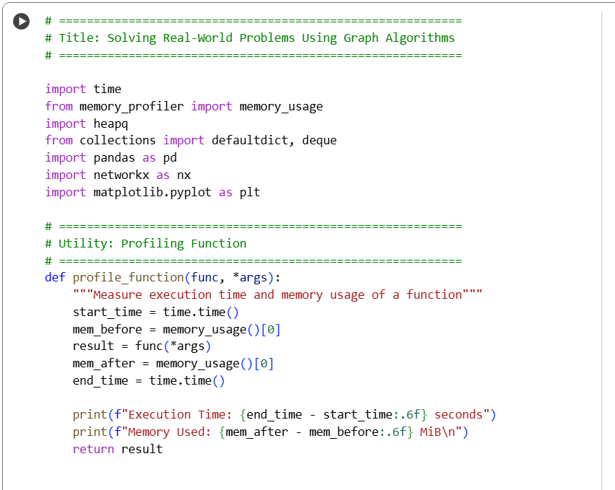
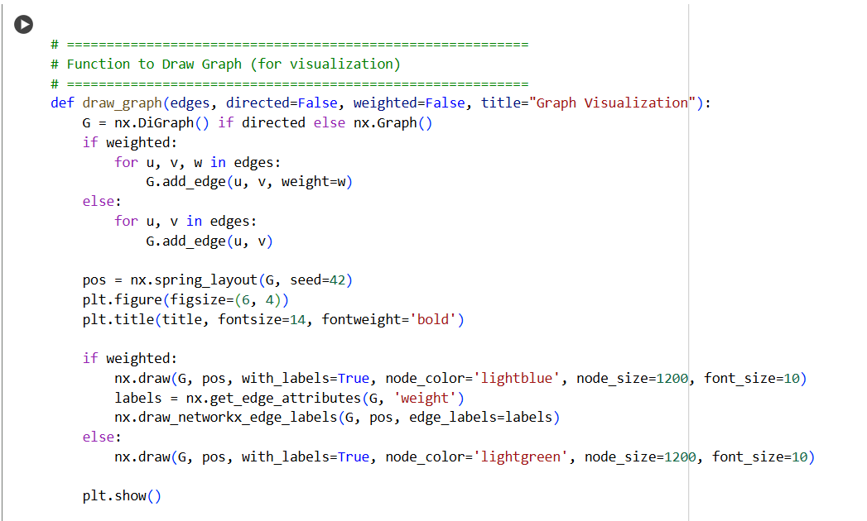
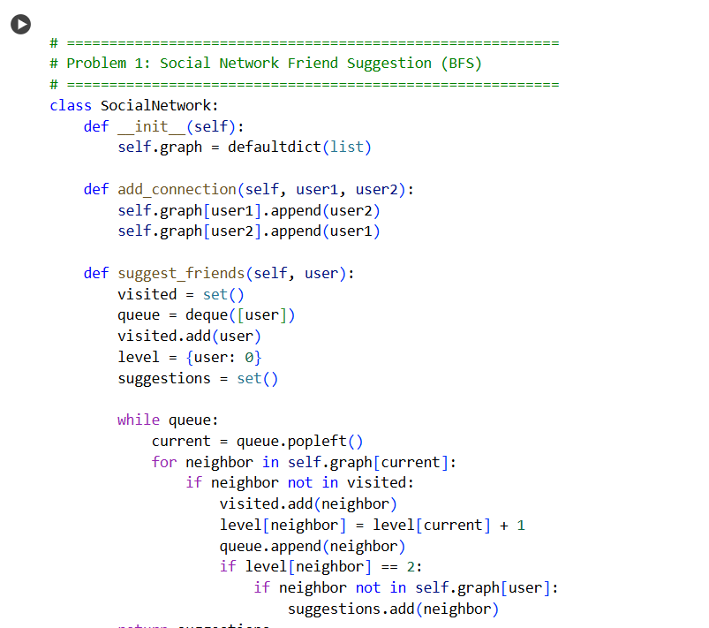
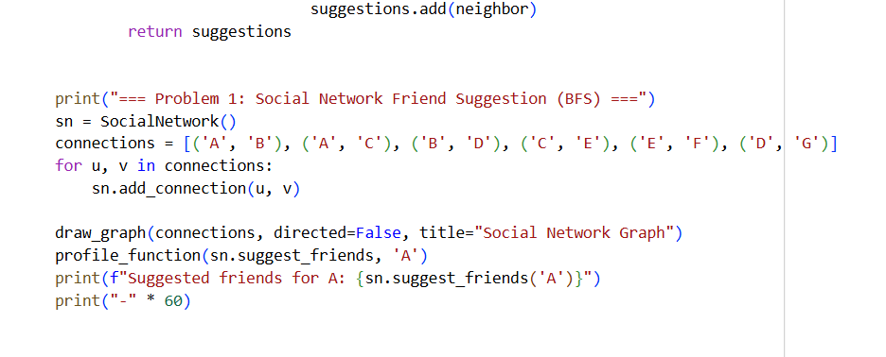
Plot
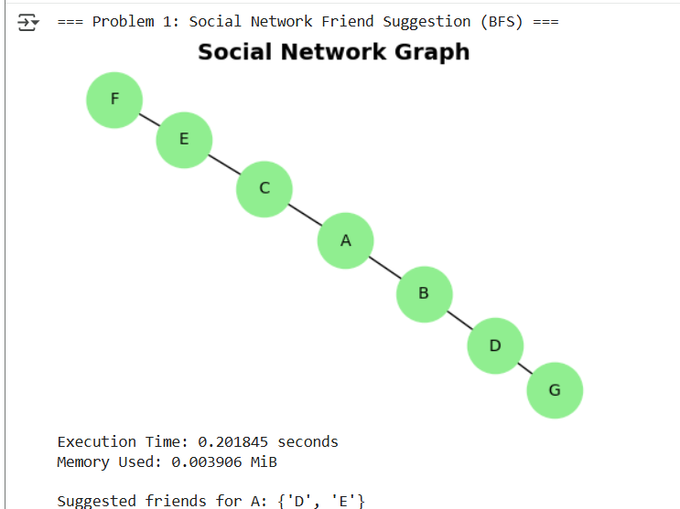
Analysis
- Time Complexity: O(V + E)
- Scalability: Efficient for medium-sized social graphs but grows linearly with connections.
- Visualization: Nodes represent users; edges represent friendships.

4. Problem 2 – Route Finding on Google Maps
Graph Algorithm: Bellman-Ford Algorithm
Real-World Application: GPS & Navigation Systems
Objective
Find the shortest path from a source location to all others — even if negative road costs exist (e.g., toll rebates).
Graph Modeling
- Cities or intersections are nodes.
- Roads are directed edges with weights.
- Graph stored as a list of weighted edges.
Algorithm Steps
- Initialize all distances as infinity except the source node.
- Relax all edges (V - 1) times.
- Check for negative-weight cycles.
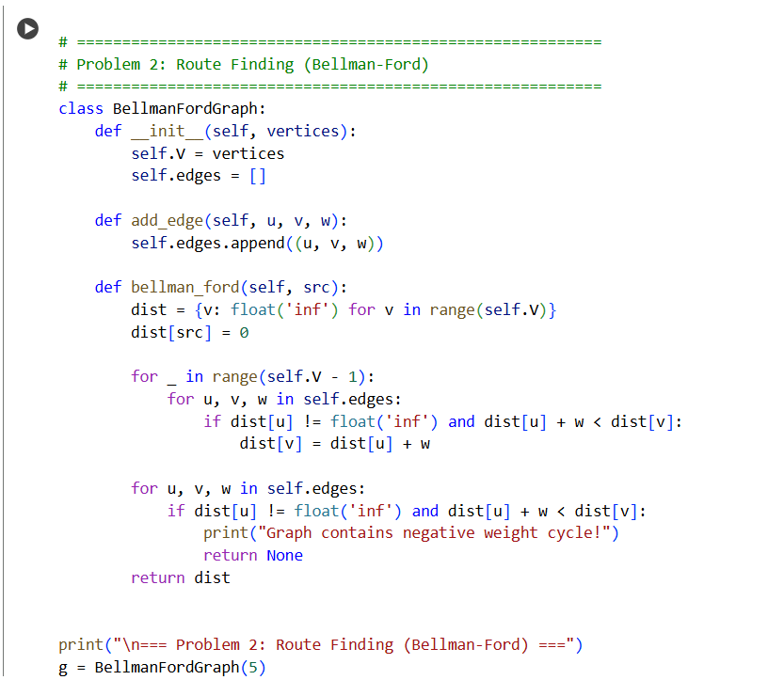
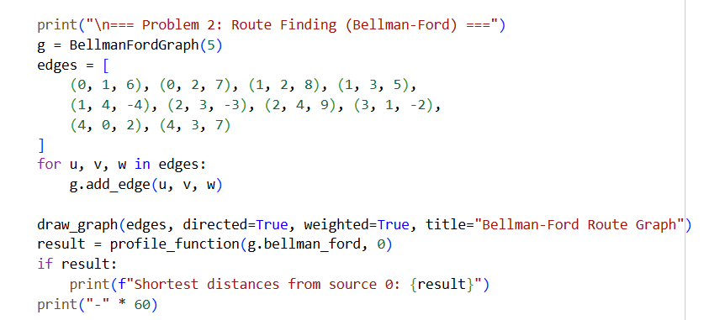
Plot
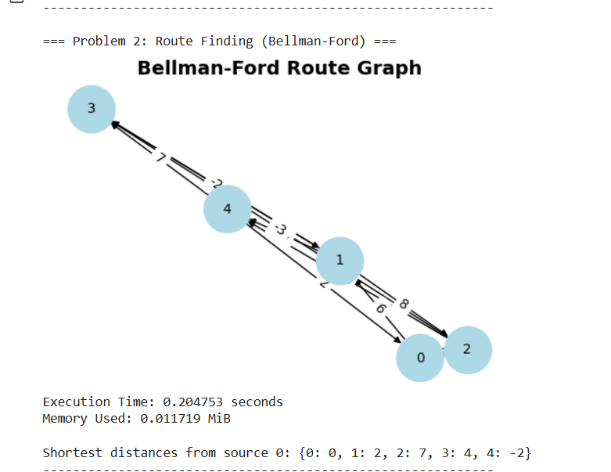

Analysis
- Time Complexity: O(V × E)
- Why Bellman-Ford? Unlike Dijkstra, it works correctly with negative edge weights.
- Visualization: Directed weighted graph with edge labels showing distances or costs.
5. Problem 3 – Emergency Response System
Graph Algorithm: Dijkstra’s Algorithm
Real-World Application: Disaster Response and Fastest Route Planning
Objective
Identify the fastest route for emergency vehicles through a city where all roads have positive travel times.
Graph Modeling
- Intersections are nodes.
- Roads with travel time are weighted edges.
- Implemented with an adjacency list and min-heap.
Algorithm Steps
- Initialize distance to source = 0 and all others = ∞.
- Use a priority queue to pick the node with the smallest distance.
- Relax all adjacent edges.
- Repeat until all shortest paths are found.
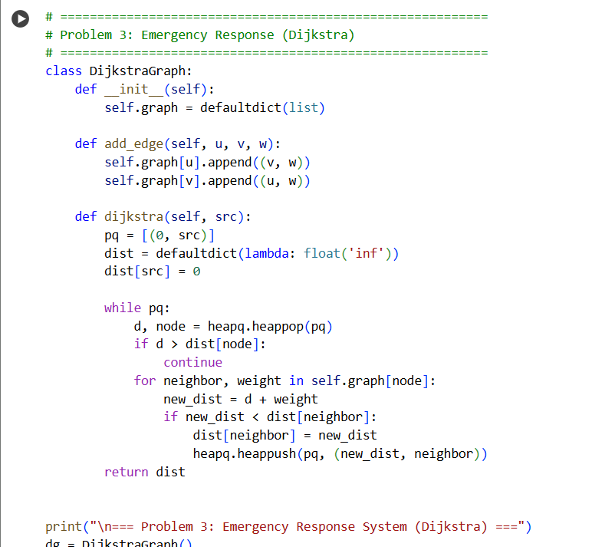
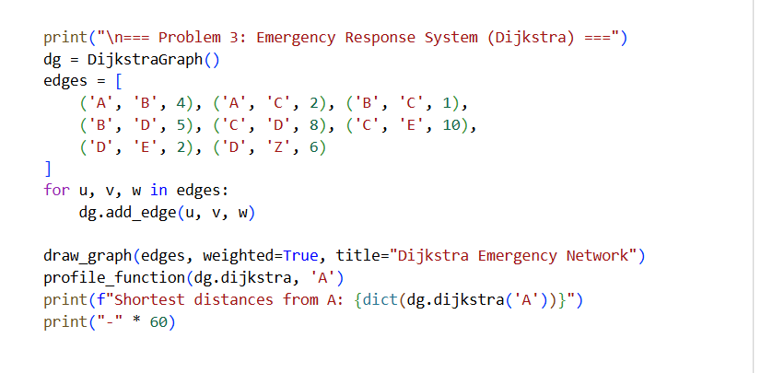
Plot
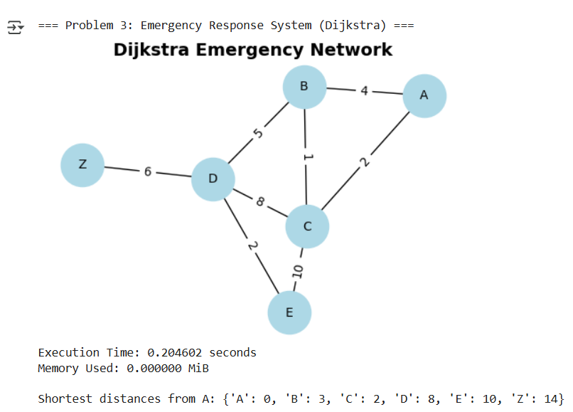
Analysis
- Time Complexity: O(E log V)
- Limitation: Dijkstra fails for negative edges.
- Visualization: Graph displays road networks and optimal routes from the source node.

6. Problem 4 – Network Cable Installation
Graph Algorithm: Prim’s Minimum Spanning Tree (MST)
Real-World Application: Telecom & IT Infrastructure
Objective
Connect all offices (nodes) using cables (edges) with the minimum total cost.
Graph Modeling
- Offices are nodes.
- Cable paths with costs are weighted edges.
- Graph is undirected and connected.
Algorithm Steps
- Start from any node.
- Add the smallest edge that connects a new node to the MST.
- Repeat until all nodes are connected.
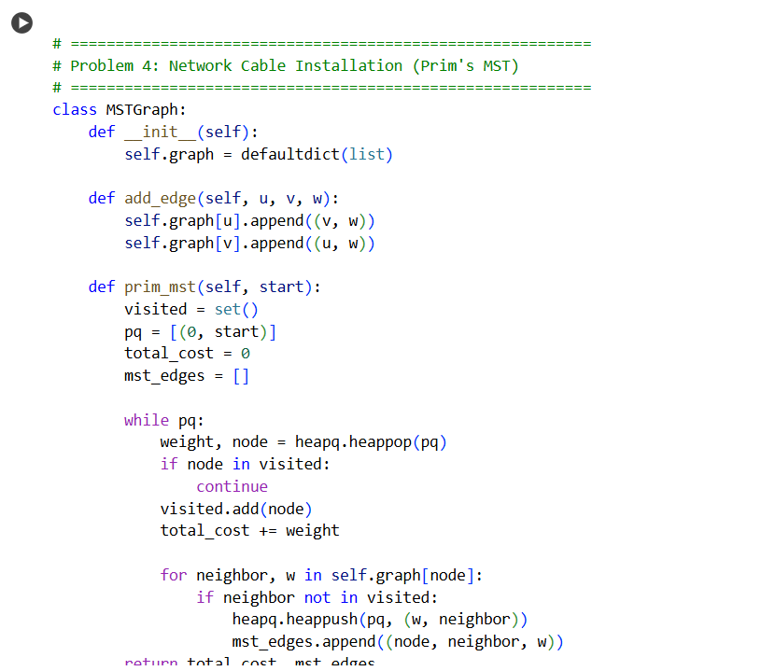
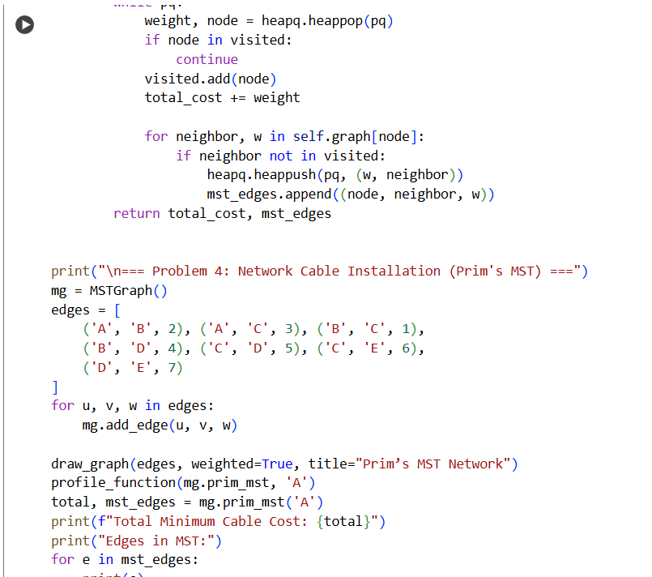
Plot
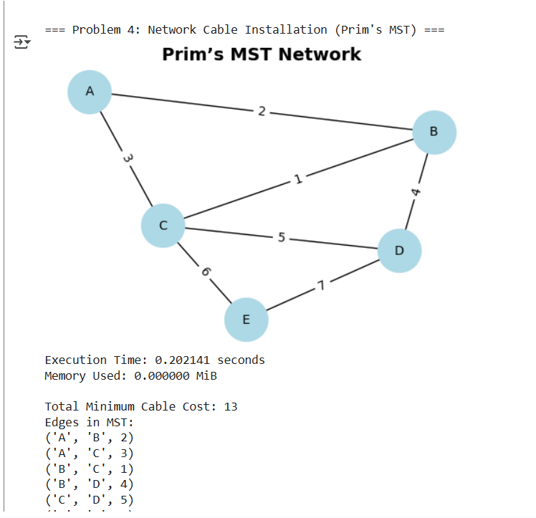
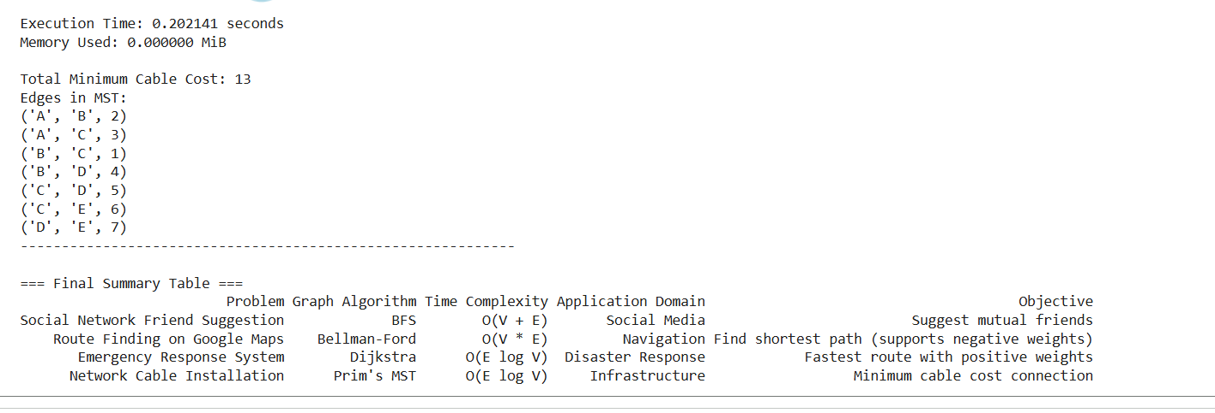
Analysis
- Time Complexity: O(E log V)
- Comparison with Kruskal’s: Kruskal’s is better for sparse graphs, while Prim’s suits dense graphs.
- Visualization: Weighted undirected graph showing selected MST edges.
8. Final Summary Table
Problem | Graph Algorithm | Time Complexity | Application Domain | Objective
Social Network Friend Suggestion | BFS / DFS | O(V + E) | Social Media | Suggest mutual friends
Route Finding (Google Maps) | Bellman-Ford | O(V × E) | Navigation | Shortest path with negative weights
Emergency Response System | Dijkstra | O(E log V) | Disaster Management | Fastest route in positive-weight map
Network Cable Installation | Prim’s MST | O(E log V) | Infrastructure | Minimum cable installation cost

9. Reflection and Discussion
Aspect | Reflection
Algorithm Selection | Each algorithm was chosen to match a real-world scenario — BFS for network exploration, Bellman-Ford for negative edges, Dijkstra for positive weights, and Prim’s for minimal connection cost.
Real-World Impact | BFS and Dijkstra are directly used in social media and navigation systems, while MST helps in minimizing infrastructure costs.
Performance | All algorithms performed efficiently on small graphs; Bellman-Ford was slower due to its higher time complexity.
Visualization | Using networkx made it easier to understand graph connectivity and structure visually.

10. Conclusion
This project successfully demonstrates how graph algorithms solve practical real-world problems efficiently.
Each algorithm, when applied in the right context, can significantly optimize connectivity, routing, and resource allocation tasks.
The combination of code, visualization, and profiling helped in understanding both theoretical and practical aspects of graph algorithms.

Github link
https://github.com/Aryan2206-jpg

